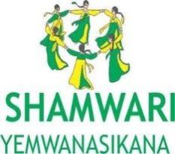

BASELINE SURVEY
for the

Enhancing partnership to improve service provision in Sexual Reproductive Health for adolescent girls in Zimbabwe

PROJECT

Prepared by
Tafadzwa Hove
Independent Social Development Consultant
2422 New Marlborough; Harare
tafiehove@gmail.com
+263773944465

Acronyms

AGYW Adolescent Girls and Young Women
CCCC Chiedza Child Care Centre
YP Young People
ZDHS Zimbabwe Demographic Health Survey
SRH Sexual Reproductive Health
HIV Human Immuno-Deficiency Virus
STIs Sexually Transmitted Illnesses
ASRH Adolescent Sexual Reproductive Health
MICS Multiple Indicators Cluster Survey
ART Anti-Retroviral Treatment
OECD/DAC Organisation for Economic Corporation and Development/ Development Assistance Committee
FGD Focus Group Discussions
KII Key Informant Interviews
ToR Terms of Reference

Table of Contents

Acronyms i
Table of Contents ii
Executive Summary iv
1 Introduction 1
1.1 Background Context 1
1.2 Project Overview 1
1.3 Purpose and Objectives of the Baseline Assessment 2
2 Methodology 2
2.1 Methods of Data Collection 2
2.2 Ethical Considerations 3
2.3 Characteristics of the Survey Sample 3
3 Findings 4
3.1 Access to SRH Information and Services 5
3.1.1 Levels of uptake of SRH services 5
3.1.2 Barriers for young people to access SRH Services 6
3.1.3 Demand for SRH Services 7
3.2 Knowledge on Sexual and Reproductive Health and Life Skills 8
3.2.1 Knowledge of HIV and AIDS 8
3.2.2 Myths and Conception on HIV and AIDS 8
3.2.3 Knowledge of SRH Rights for Young People 9
3.3.4 Knowledge on SRHR Strategic and Policy Issues 10
3.3 ASRH Attitudes and Beliefs 10
3.3.1 Attitudes on Use of Contraception 10
3.3.2 Perceptions on SRH Knowledge and Contraceptive Use 11
3.3.3 Reliability of SRH Information Sources 12
3.4 Adolescents Sexual Behaviours and Practices 13
3.4.1 Exposure of Young People to Sex and Contraception 13
3.4.2 HIV Testing and Prevention Patterns among Young People 15
3.4.3 Level of Risk to HIV among Young People 16
3.5 Gender Roles 17
3.5.1 Decision Making in the Home 17
3.5.2 Perception of Gender Based Violence and Early Marriages 17
4 Conclusions and Recommendations 18
4.1 Conclusion 18
4.2 Recommendations 19
References 21
Questionnaire 22

Table of Figures
Figure 1: Proportion of Respondents who received SRH Services in the last 12 months (n=254) 5
Figure 2: Proportion of young people who received SRH services in the last year by sex (n=254) 5
Figure 3: Comfort with visiting nearest health facility (n=254) 6
Figure 4: Distance to Place for Accessing SRHR services (n=254) 7
Figure 5: Proportion of Respondents who would seek for SRH services (n=254) 7
Figure 6: Percentage of young people seeking SRH service by age-group (n=254) 8
Figure 7: Proportion of Respondents who heard about HIV and AIDS by Age Group (n=254) 8
Figure 8: Level of Knowledge SRH Rights (at least 2) (n=254) 9
Figure 9: Young People Attitudes on Use of Contraception (n=254) 10
Figure 10: Young People Attitudes on Use of Contraception by age (n=254) 11
Figure 11: Perception that SRH Knowledge leads to Promiscuity (n-254) 11
Figure 12: Approval of Young Unmarried Youths Using Contraception (n=254) 12
Figure 13: Perception on making informed decisions about sexual behaviour and relationships (n=254) 12
Figure 14: Most reliable source of information for young people (n=254) 13
Figure 15: Respondents who have ever had sexual intercourse before (n=254) 13
Figure 16: Respondents who have had sexual intercourse before by age (n=254) 14
Figure 17: Young People using Any contraception method (n=254) 14
Figure 18: Respondents who have been tested (n=254) 15
Figure 19: Respondents knowing the ABC to Prevention of HIV and AIDS (n=254) 15
Figure 20: Perception of Risk among young people interviewed (n=254) 16
Figure 21: Most Important Decision Made at Home (n=254) 17

Table 1: Characteristics of the Survey Sample (n=254) 4
Table 2: Barriers of young people seeking SRH services (n=254) 6
Table 3: Respondents with wrong conception of HIV and AIDS (n=254) 9
Table 4: Level of Knowledge on SRHR Strategic and Policy Issues (n=254) 10
Table 5: Standard Tool to Ascertaining Risk for young people 16
Table 6: Perception of young males and females on acceptability of early marriages (n=254) 17
Table 7: Perception of Young People on Domestic Violence (n=254) 18

Executive Summary
Introduction: The “Enhancing partnership to improve service provision in Sexual Reproductive Health for adolescent girls in Zimbabwe” is a project being run through a coalition of the following organisations; Chiedza Child Care Centre, Youth Advocates Zimbabwe and Shamwari Yemwanasikana in 3 districts of Zimbabwe – Seke, Chitungwiza and Zvimba. The coalition hired an independent consultant to develop a report after the data collection had been done by the partners. The baseline assessment was meant to generate information to inform and refine programme activities, indicators and implementation strategies. With the baseline assessment provides a good foundation for planning, monitoring and evaluation of the project through its cycle.

Methodology: The baseline is solely quantitative with information gathered also through secondary data collection and analysis. All ethical consideration as ascribed standards of research where followed. A total of 254 questionnaires were administered to 201 young females (10-24) and 53 young males (10-24) in the three districts of Seke, Chitungwiza and Zvimba. Data was analysed through SPSS and used to report of the findings of the study.

FINDINGS

Access to SRH Information and Services: Overall, 42.9% of young respondents interviewed had gone to a health facility in search of SRH services within the last 12 months with Zvimba recording 63.6% due to it having been included in the previous phase of the same project. A relatively higher proportion of 54.7% males had accessed the services in comparison to 39.8% for their female counterparts. A percentage of 80.3% of young people were comfortable with visiting the nearest/local health facility with Zvimba having the highest proportion with 91.2% while Chitungwiza and Seke was at 66.7% and 83.3% respectively. Significant barriers for access to services and information were issues of stigma from peers and community (42.3%) and the cost at the hospital/clinic (33.4%) and negative attitude of staff (23.4%). Distance to a health facility was also an issue where 10.2% of respondents feel services were far from their residence. In Seke, 18.33% of respondents have their nearest SRH services beyond 8km radius, and 8.49% in Chitungwiza shared the same sentiments. However, in Chitungwiza, 51.89% of the respondents have the nearest place to access SRH services within 1 km, while all respondents in Zvimba are within the 1-3km radius. Due to demand creation activities having been rolled out in the predecessor phase demand for services was highest in Zvimba with 97.7% of those interviewed in the district demanding more services while 35.8% in Chitungwiza and 15% in Seke demanded SRH services and knowledge.

Knowledge on SRH and Life Skills: A proportion of 92.5% of young people interviewed had heard of HIV and AIDS. It was however shocking that there were some misconceptions on HIV including; 14.6% believing that HIV can be transmitted through witchcraft and supernatural powers, 18.9% believing that a person who looks healthy does not have HIV and only 12.2% of young people interviewed believed that HIV can be passed from mother to child. Knowledge on SRH rights was low, with only 25% of young people interviewed knowing at least 2 sexual and reproductive health rights. Knowledge of policy and strategic elements for SRHR for young people was generally low, with 2.4% of the young people knowing about the National Adolescents and Reproductive Health Strategy (2016-20), 39.8% having knowledge of the Domestic Violence Act and 53.1% having heard about the Children’s Act.

ASRH Attitudes and Beliefs: A proportion of 52% young people interviewed said they would use contraception when they have sexual intercourse either for the first time or next time. This uptake could be due to perception of contraception where 46.6% had the perception that knowledge on SRH could lead to promiscuity of young people. There is also low perception on whether it is proper for young people to use contraception when married, with 36.6% of interviewed young people feeling that it is possible to use contraception when one is unmarried. A proportion of 53.5% of respondents felt that they can make informed decisions on sexual behaviour and relationships. The health facility was hailed as the most reliable source of SRH iformation by the young people interviewed with 38.2% sharing the proclamation. The mother and aunt were also important sources of information especially among females (mother – 28.4%; aunt – 22.4%) and less among the males where they recorded 9.4% and 5.7% for mother and aunt respectively.

Adolescent Sexual Behaviours and Practices: A proportion of 72% young people interviewed had never engaged in sexual intercourse, while 2% did not respond to the question. There is a relatively lower proportion (2.8%) of 10-14 age groups having had sexual intercourse, and there is a distinct increase in exposure to sexual behaviour with age as 29.3% of those in the 15-19 age groups having had sexual intercourse and a much greater proportion of those in the 20-24 where 41.9%. A proportion of 44.5% of young people had been tested before and all those tested in all areas had received their results. A proportion of 28.3% males and 27.4% of females knew about the ABC to prevention. After the young person had been shown the categories of risk to HIV, 35% of young people perceived they are in the high risk zone, where 37.3% of females and 26.4% of males perceived themselves to be in the high risk zone.
Gender Roles: Young people interviewed in the study, demonstrated the power imbalance in decision making at family level where 41% of the young people interviewed felt that the man makes the important decisions and 37% also felt that a decision made equally between the man and the woman was the most important and 18% felt the woman’s decision was the most important. A proportion of 10.2% of young people interviewed felt that it is acceptable to have early marriages with a bigger sample of males (15.1%) than that of females (9%). The same trend was observed on domestic violence where 18.9% males felt it is acceptable as opposed to 9.5% of females.
Recommendations

- Put in place a full-fledged capacity strengthening for all partners and key stakeholders to be able to create a standard modus operandi and to ensure that the same results are being pushed in all areas, that will also improve monitoring and evaluation efforts;

- Create synergies with service providers for mobile youth friendly centres where young people can receive SRH services for free or at reasonable prices;

- Upscale to other new areas in Zvimba and still service existing areas for greater impact and to reduce duplication and also provide services that are tailor made to the needs of the various districts being cognisant of the different needs particularly due to Zvimba having received some services before the roll out of this project;

- Increase the scope of the project to include school based programming to improve reach;

- Conduct youth friendly and demand creation activities that appeal to young people to include use of creative arts, sports, school based entertainment;

- Create a vibrant roster and conduct family and community based awareness and sensitisation on the gains of the project and the importance for young people in order to reduce societal, family and peer stigma and also to be enable the community and family to be reliable sources for SRH information;

- Provide a youth-specific knowledge programme with age and sex specific lessons detailed in a manual guided by the nuances of the study Issues of contraception should also be topical;

- Social accountability should also be included where the young people are fully inducted on various policies and strategies on SRH and young people and how they can as themselves hold office bearers accountable for any variance with such;

- Mainstream gender issues in the planning, implementation, monitoring and evaluation; and include issues of gender transformation in all sensitisation, awareness, training sessions of the community, service providers, young people and all stakeholders;

- Wedge a multi-sectoral approach were all key stakeholders participate actively and own the project at community level;

- Ensure adequate and frequent monitoring, knowledge management and dissemination of the project at local, district, country and beyond borders for greater impact.

Introduction

Background Context

Zimbabwe’s population is dominantly young, with 62% of the population being below the age of 25 years. Adolescents and young people face a plethora of sexual and reproductive health challenges such as unplanned pregnancies, early child bearing, limited access to SRH services and information, susceptibility to sexually transmitted infections, violation of rights as well as HIV. Prevalence of HIV among adults of ages 15-64 years in Zimbabwe is 14.6% (1.2 million people living with HIV (PLHIV): 16.7% among females and 12.4% among males. According to the Ministry of Health (MOH) Spectrum (2014), HIV prevalence among the 10-14 years age group is 2.8% and 8.3% for the 15-19 years age group. Comprehensive and correct HIV knowledge is low among the 15-19 age group – 49% for boys and 51% for girls. As the ZHDS of 2015 further notes, HIV testing for girls in the 15-19 years age group stands at 47.9% and 37.6% for boys in the same age group. STI prevalence among boys in the 15-19 years age group is at 8% and at 9% among young girls in the same age group.
Major drivers to the intricate web of SRH challenges faced by young people is household and youth poverty, limited access to information and services on their SRH, inadequate relevant service delivery, and inadequate policy and regulatory framework. Household and youth poverty increase the vulnerability of adolescents to sexual and reproductive health risks. For instance, girls in poorer families are likely to drop out of school which increases their risk of either getting married or falling pregnant at younger ages, (MICS, 2014; ZDHS, 2010; ZimStat, 2012). According to the Zimbabwe National Adolescent Sexual and Reproductive Health Strategy (2010-2015), young people lack comprehensive knowledge on SRH issues and services and this exposes them to various SRH and related challenges. Youth poverty also undermines access of adolescents and young people to ASRH services such as treatment for STIs, HIV testing, contraceptive and condoms. The weak financial muscle which characterises both rural and urban youth prohibits them from paying for SRH services hence widening their vulnerability context.

Project Overview

The “Enhancing partnership to improve service provision in Sexual Reproductive Health for adolescent girls in Zimbabwe (from Sept 2018 to Aug 2020) ” is a project being run through a coalition of the following organisations; Chiedza Child Care Centre, Youth Advocates Zimbabwe and Shamwari Yemwanasikana in 3 districts of Zimbabwe – Seke, Chitungwiza and Zvimba. A similar project had been run by Chiedza Child Care Centre between July 2017 and December 2018) and so the main thrust of this phase of the project was to strengthen collaboration and increase the voice and also to upscale in Zvimba while moving into other areas specifically – Seke and Chitungwiza. The project seeks to create a vibrant partnership which will enable adolescent girls to access quality and cost effective sexual reproductive health resources, information and services in Harare, Chitungwiza and Zvimba district by 2020. Young people especially girls face unprecedented challenges related to their sexual and reproductive health and these include high levels of teenage pregnancies, gender based violence, child marriages and new HIV infections. Faced with a myriad of these challenges, it is sad to note that victims (girls) often have inadequate information about their health and legal rights to access prompt treatment, reporting to the police and a fair trial. It is against this background that the project seeks to increase individual awareness on SRHR. The project objectives are as follows;

- To provide ongoing support, mentoring and training to two small civil society organisations implementing SRHR programs in Zimbabwe by 2020,

- To reach out to young people especially adolescent girls with quality and cost effective SRH services by 2020,

- To generate new evidence on SRHR which can be used for evidence based advocacy and policy engagement in Zimbabwe by 2020 and;

- To engage with service providers to actively support SRHR for all populations by 2020

Purpose and Objectives of the Baseline Assessment

The baseline assessment is fundamental to enable effective monitoring and evaluation of the project by establishing baseline values of the programme. In addition, the assessment will be used to generate more information to inform and refine programme activities, indicators and implementation strategies.

The specific objectives of this assignment are to:

- Assess the access and barriers to access to sexual and reproductive health of young people (10-24);
- Assess the knowledge and attitudes and beliefs on sexual and reproductive health and life skills for young people;
- Determine adolescents sexual behaviours and practices within all communities selected for the project;
- Understand how stakeholders and communities are working together to strengthen their collaboration on providing support to young people (10-24);
- Provide recommendations for the implementation and monitoring of the project.

Methodology

The baseline assessment used quantitative data and literature review so as to define the challenges, attitudes, perceptions and practices of young people who were interviewed. The baseline assessment was done in all three districts (Chitungwiza, Seke and Zvimba) although the data collection in Zvimba coincided with the end-line evaluation within the last phase. The same questionnaire was used for both end-line and baseline and the data sets were merged for analysis and reporting.

Methods of Data Collection

Secondary Data Collection: Literature Review - The document review and analysis was important in providing for (i) situational context, (ii) stakeholder mapping for key informant interviews and (iii) statistical data collection. The documents reviewed included: Project Sub-award document; evaluation document for the previous phase; project documents; monitoring reports; and national level studies and statistics. Literature review also included regional and international related documents, best practices and lessons learnt.

Quantitative Data Collection: Survey – A one-on-one questionnaire was administered to young people and was meant to assess the level of understanding of Determination of Knowledge/Understanding Perceptions, Attitudes and Behaviours /Practices before the intervention. The tool used for the previous phase evaluation of the project was adapted and utilised for the baseline for easy of comparison and assessment of progress against the results for Zvimba. Survey data collected through the administration of the questionnaire was analysed through SPSS.

Ethical Considerations

The Survey team observed the following:

- The Survey Team observes the law of the country when dealing with all citizens.
- Clearances were sourced from relevant authorities in districts visited for fieldwork.
- Full consent was obtained from the participants before everything else because voluntary participation in the evaluation is a priority (Consent forms developed for the evaluation).
- Ensured that participants understand the nature of the research and their involvement and that they can opt out without prejudice.
- Research participants were not subjected to harm in any way.
- Respect for the dignity of research participants was prioritized.
- The protection of the privacy and anonymity of individuals participating in the evaluation was ensured (participants will not be identified in report).
- Confidentiality of the evaluation data was ensured and participants assured of this. Where there is need to refer a case then the participant is informed of shared confidentiality (consent form).
- Any deception or exaggeration about the aims and objectives of the evaluation were avoided.
- Any type of communication in relation to the evaluation was done with honesty and transparency.
- Any type of misleading information, as well as representation of primary data findings in a biased way was avoided.
- Highest level of objectivity in discussions and analyses was maintained throughout the evaluation.

Furthermore, the evaluation took cognisance that marginalised and vulnerable groups, who in some cases may be living with HIV or might have gone through forms of gender based violence, were involved in the consultations. It was, therefore, important that the evaluation adhered to ethical standards for interviewing vulnerable people.

Characteristics of the Survey Sample

Of the 254 young people who participated in the survey, 41.7% were from Chitungwiza; 34.6% from Zvimba and 23.6% from Seke. The majority (79.1%) of young people were female, while 46.5% were in the 15-19 years age group and 25.2% were aged 20-24 years. A proportion of 55.1% were either in secondary school level education or attained secondary schooling as the highest education level, with 36.6% of them currently having attained primary school as their highest level of education. Assessing their marital status, 77.2% of the young people had never been married, with 16.1% married and living with spouse, 2.8% are married but not living with spouse. The remaining 3.6% were divorced/separated, while 1 (0.4%) was widowed (Table 1).

Table 1: Characteristics of the Survey Sample (n=254)
Characteristic | Frequency | Percentage
Total | 254 | 100
District  Chitungwiza  Seke  Zvimba | 88  106  60 | 34.6  41.7  23.6
Sex  Female  Male | 201  53 | 79.1  20.9
Age  10-24  15-19  20-24 | 72  118  64 | 28.3  46.5  25.2
Education  Never Attended  Primary  Secondary  High School  Vocational Training College  University/Polytechnic | 5  93  140  9  2  5 | 2  36.6  55.1  3.5  0.8  2
Marital Status  Never Married  Married and living with spouse  Married but not living with spouse  Divorced/separated  Widowed | 196  41  7  9  1 | 77.2  16.1  2.8  3.6  0.4
Religion  Traditional  Christian  Muslim  Apostolic  None | 5  160  8  57  24 | 2  63  3.1  22.4  9.5

Findings

The baseline findings are categorised to the themes of the survey which are as follows;
- Access to SRH Information and Services (3.1)
- Knowledge on Sexual and Reproductive Health and Life Skills (3.2)
- ASRH Attitudes and Beliefs (3.3)
- Adolescents Sexual Behaviours and Practices (3.4)
- Gender Roles (3.5)
The section provides findings and discussion on each section as follows;

Access to SRH Information and Services

Levels of uptake of SRH services

Overall, 42.9% of young respondents interviewed had gone to a health facility in search of SRH services within the last 12 months (one year) Uptake of SRH services among young people were highest among young people in Zvimba, where 63.6% young people visited health facilities in search for SRH services, with 25% (Seke) and 35.8% (Chitungwiza) of young people visited health facilities to seek SRH services in the last 12 months. The proportion in Zvimba could also be attributed to the project having been rolled out before in the community, while in Seke and Chitungwiza they are still starting although there could have been other projects of similar nature running in the community. Figure 1 shows the proportion of respondents who sought SRH services in the last 12 months before the study disaggregated by districts.
Figure 1: Proportion of Respondents who received SRH Services in the last 12 months (n=254)
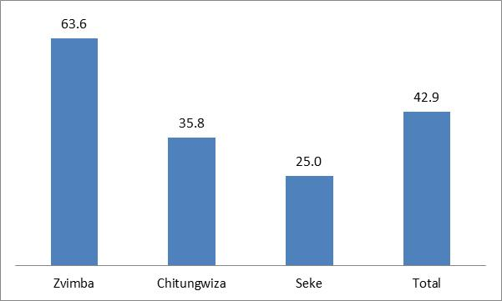
More young males were seeking SRH services than young females: A proportion of 54.7% of young males had gone for SRH services against the proportion of 39.8% of young females who took up SRH services in the last 12 months. The discrepancy is against the reality that most projects in most districts are targeting young females rather than young males. The issues might be based on gender inequality norms where boys are allowed to explore while girls are more bound to the home. Figure 2 shows the proportion of young people who received SRH services in the last 12 months before the project disaggregated by sex.
Figure 2: Proportion of young people who received SRH services in the last year by sex (n=254)
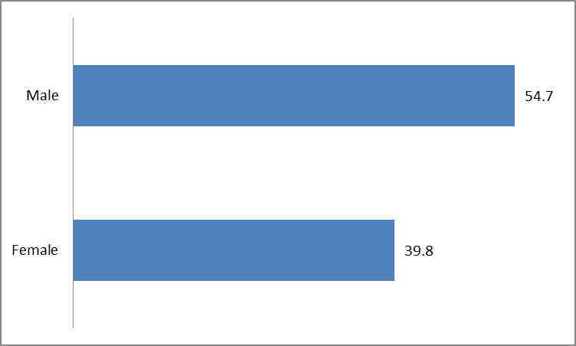

Young people are generally comfortable with visiting the closest health facility: A proportion of 80.3% of young people were comfortable with visiting the nearest/local health facility. Like the trend, Zvimba has the highest proportion of respondents comfortable with visiting the closest health facility, with 91.2% of respondents displaying that they are comfortable while Chitungwiza and Seke was at 66.7% and 83.3% respectively. Figure 3 shows the proportion of respondents who were comfortable with visiting the nearest health facilities.
Figure 3: Comfort with visiting nearest health facility (n=254)
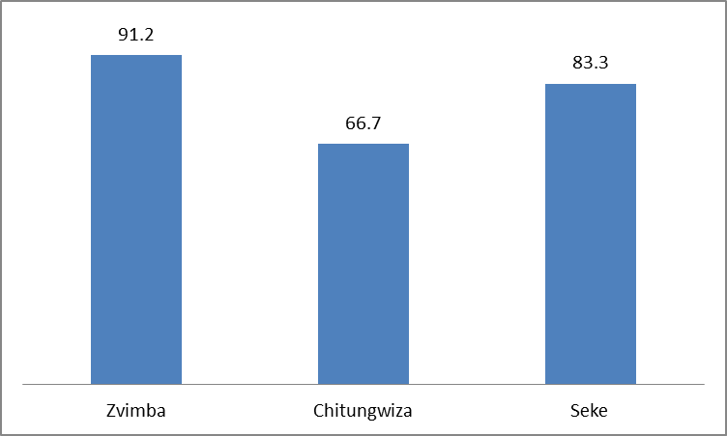

3.1.2 Barriers for young people to access SRH Services

During the study, young people were asked to state which barriers they feel are the most detrimental in their access to SRH services. The most significant barriers were the issues of stigma from peers and community (42.3%), the cost at the hospital/clinic (33.4%) and negative attitude of staff (23.4%). Inconvenient working hours (2.3%) and lack of confidentiality (3.4%) are highly insignificant and can be held as important barriers to guide project implementation. Table 2 shows the identified predetermined barriers that young people believed were barriers to access to SRH services;
Table 2: Barriers of young people seeking SRH services (n=254)
Barriers | Proportion agreeing with each barrier
Negative Attitude from staff at local health facility | 23.4%
Inconvenient working hours | 2.3%
Cost at the local clinics/hospital | 33.4%
Long distances | 10.2%
Labelling or stigmatisation from peers and community | 42.3%
Unavailability of services at local health facility | 9.8%
Lack of confidentiality | 3.4%

Distances to health centres and clinics are within reach although some are far: As in Table 2, 10.2% of respondents expressed distance as a barrier to SRH services. In Seke, 18.33% of respondents have their nearest health facility offering SRH services beyond the standard 8km radius, while there were also 8.49% in Chitungwiza sharing the same sentiments. However, in Chitungwiza, 51.89% of the respondents have the nearest place to access SRH services within 1 km, while all respondents in Zvimba are within the 1-3km radius. Figure 3 shows, distances to nearest place for accessing SRHR services.

Figure 4: Distance to Place for Accessing SRHR services (n=254)
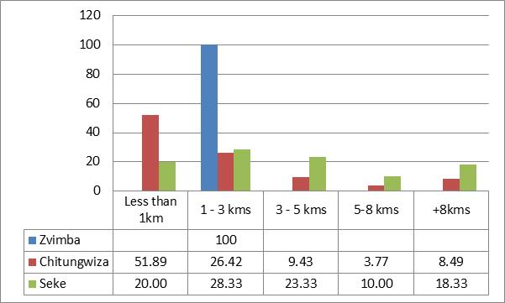

3.1.3 Demand for SRH Services

Demand for services is clearly highest in Zvimba (97.7%), which could also be attributed to demand creation activities that had been done in the last phase of the project. Overally, 52.4% of study respondents want to seek SRH services, while 35.8% in Chitungwiza and 15% in Seke, which could be attributed to them not going through the project in the last phase. Figure 5 shows the proportion of respondents who would seek SRH services for the first time or again.
Figure 5: Proportion of Respondents who would seek for SRH services (n=254)
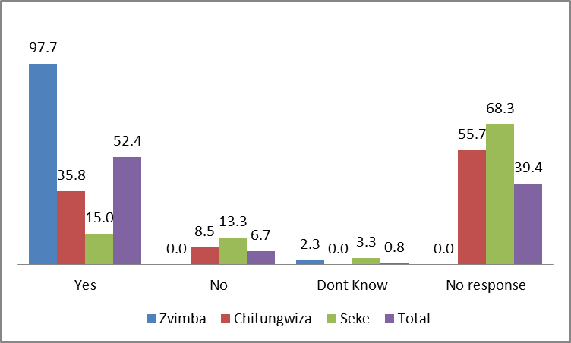
Demand is highest in the 15-19 age groups and lowest in the 10-14 year age group: Statistics reveal that 65.25% of young people aged 15-19 would want to receive SRH services and 57.8% among the 20-24 age group. The 10-14 age groups has generally low demand of SRH services, which could be attributed to their awareness of risk and lower exposure to sexual intercourse. Figure 6 shows the percentage of young people seeking SRH services by age group;
Figure 6: Percentage of young people seeking SRH service by age-group (n=254)
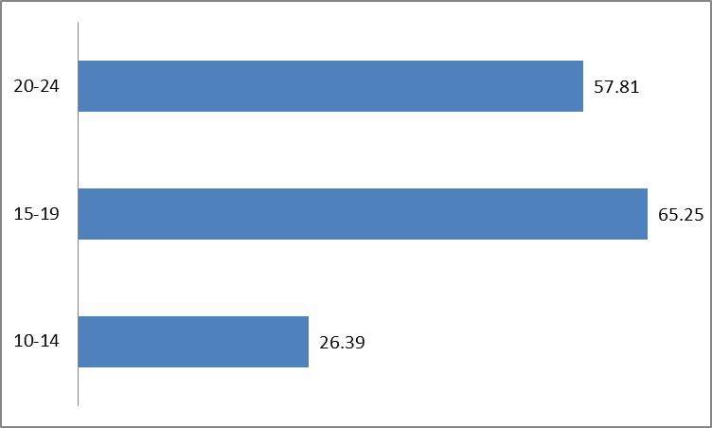

Knowledge on Sexual and Reproductive Health and Life Skills

3.2.1 Knowledge of HIV and AIDS

A proportion of 92.5% of young people interviewed had heard of HIV and AIDS. The proportion seems to increase with age with 98.4% of those young people aged between 20-24 years having heard about HIV while 96.6% of those in the 15-19 years age group also having heard about HIV and AIDS. A relatively lower percentage of those in the 10-14 years age group had heard about HIV and AIDS at the time of the study. Figure 7 shows respondents who had heard about HIV and AIDS.
Figure 7: Proportion of Respondents who heard about HIV and AIDS by Age Group (n=254)
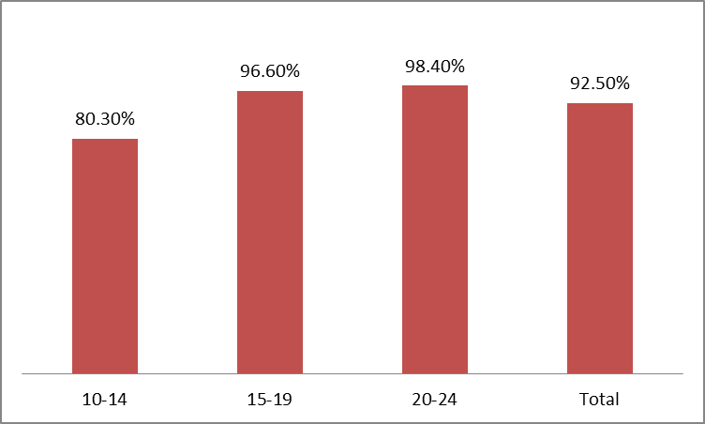

3.2.2 Myths and Conception on HIV and AIDS

The respondents were asked to give an answer on commonly known myths and conceptions. There were a number of misconceptions, with 18.9% of young people believing that a person who looks healthy does not have HIV, and 19.6% saying they would not buy vegetables from someone who is HIV positive. A proportion (14.6%) of young people interviewed believed that HIV can be passed on through witch-craft and super natural means. Only 12.2% of young people interviewed believed that HIV can be passed from mother to child. Table 3 shows respondents with wrong conception of HIV and AIDS transmission.
Table 3: Respondents with wrong conception of HIV and AIDS (n=254)
Statement | Those who answered wrongly
People can get infected by HIV and AIDS through witch-craft and super natural means | 14.6%
People can get HIV and AIDS by getting injections used on someone with HIV and AIDS | 10.2%
It is possible for a healthy looking person to have the HIV virus | 18.9%
HIV virus can be transmitted from mother to baby | 12.2%
Would you buy vegetables from a person with HIV? | 19.7%

3.2.3 Knowledge of SRH Rights for Young People

Adequate knowledge was just for the young people to be able to know at least 2 sexual and reproductive health rights. A proportion of 25% of young people interviewed knew at least 2 SRH rights while the remaining 75% were unable to know any of the SRH rights with some of them knowing only one right. This shows that there is definitely low knowledge on SRH rights for young people. Figure 8 shows the level of knowledge of at least 2 SRH rights by young people interviewed.
Figure 8: Level of Knowledge SRH Rights (at least 2) (n=254)
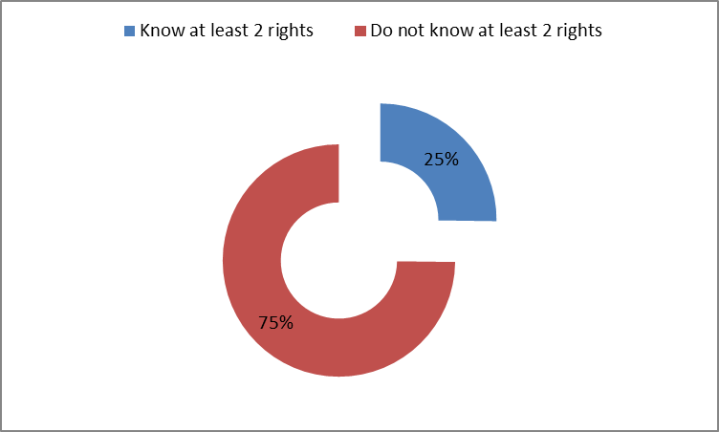

3.3.4 Knowledge on SRHR Strategic and Policy Issues

There are varied knowledge levels on key strategies and policies that are related to SRH issues for young people. Only 2.4% of young people knew about the National Adolescents and Reproductive Health Strategy (2016-20), this is against the reality that it is going to an end and has been in existence for 3 of the 5 years. Knowledge on the Domestic Violence Act (39.8%) and the Children’s Act (53.1%) though higher than that of the ASRH strategy, still paints a gloomy picture on the knowledge of young people of policies and strategies that affect them. How could they possibly hold duty bearers accountable if they do not know about these important documents? However, young people are conversant on some of the key provision which include the knowledge demonstrated that abortion is a crime, with 78% of the young people interviewed attesting to that. Also 75.6% of young people knew what family planning is. Table 4 shows the levels of knowledge on SRHR strategic and policy document and issues;
Table 4: Level of Knowledge on SRHR Strategic and Policy Issues (n=254)
Issue known by young person | Respondents Knowledgeable
National ASRH Strategy | 2.4%
Domestic Violence Act | 39.8%
Children’s Act | 53.1%
Abortion is a Crime | 78%
Knowledge of Family Planning | 75.6%

3.3 ASRH Attitudes and Beliefs

3.3.1 Attitudes on Use of Contraception

A proportion of 52% young people interviewed said they would use contraception when they have sexual intercourse either for the first time or next time. A proportion of 79.5% were in the affirmative as were 35.8% from Chitungwiza and 40% from Seke. The lower percentage in Chitungwiza was due to some saying they had never thought about it (19.8%) and 12.3% had no response.
Figure 9: Young People Attitudes on Use of Contraception (n=254)

The lower percentage in Seke was also due to a proportion of the young people interviewed not responding to the question. This could be attributed to the mere fact that because the project had still to be rolled out in these areas, so they are also still shy to discuss such issues. Figure 9 (above) shows the proportion of young people who are willing to use contraception in their next sexual encounter. The difference is ages also show the different presumption to use of contraception, with the 15-19 age groups (59.5%) and 20-24 age groups (51.6%) looking forward to use contraception as opposed to the 10-14 age group (39.4%). Figure 10 shows the attitudes of young people on the use of contraception.
Figure 10: Young People Attitudes on Use of Contraception by age (n=254)

3.3.2 Perceptions on SRH Knowledge and Contraceptive Use

Some young people (46.6%) have the perception that knowledge on SRH could lead to promiscuity of young people. That perception gets more significant with age as only 31% believe so among the 10-14 age groups as compared to 59% among the 20-24 age groups. Figure 11 shows the perception that SRH knowledge can lead to promiscuity among young people.
Figure 11: Perception that SRH Knowledge leads to Promiscuity (n-254)
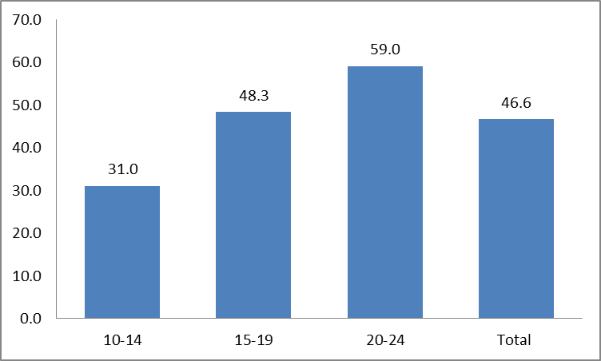
There is also low perception on whether it is proper for young people to use contraception when married, with 36.6% of interviewed young people feeling that it is possible to use contraception when one is unmarried. A proportion of 16.9% of those in the 10-14 age groups feel that there is no harm in doing so, as opposed to the other groups where, the 15-19 and the 20-24 age groups have 44% and 45.2% respectively on the affirmative. Figure 12 shows the statistics of young people approving that it is proper for them to use contraception while unmarried.
Figure 12: Approval of Young Unmarried Youths Using Contraception (n=254)
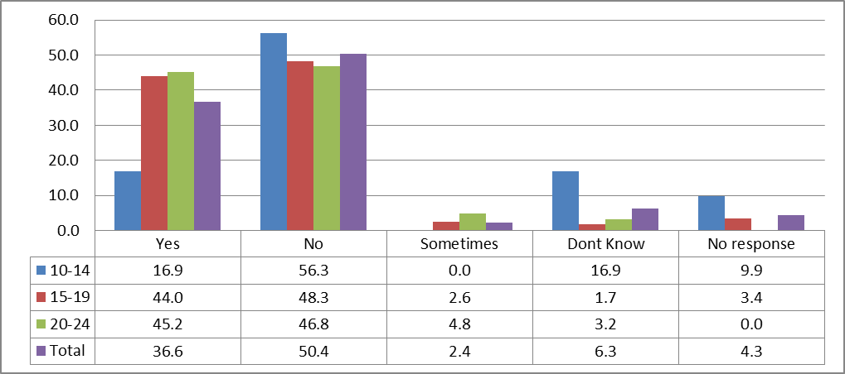
A proportion of 53.5% of respondents felt that they can make informed decisions on sexual behaviour and relationships with more males (58.5%) than females (52.2) saying that they are informed to make decision on sexual behaviour and relationships. Figure 13 shows the perception of young people on being able to make informed decisions about sexual behaviour and relationships.
Figure 13: Perception on making informed decisions about sexual behaviour and relationships (n=254)
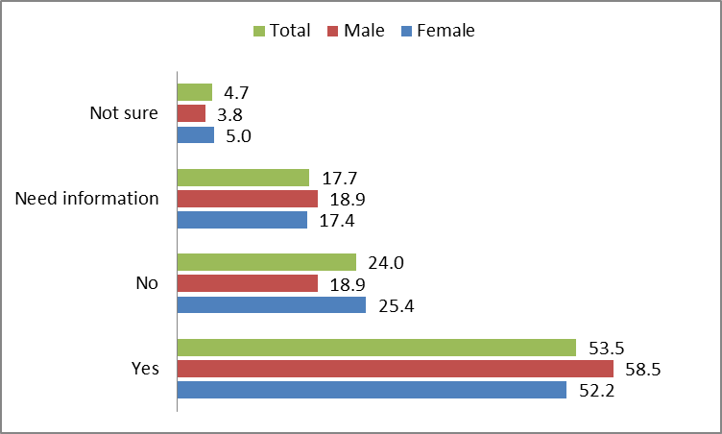

3.3.3 Reliability of SRH Information Sources

The community and family are important structures for supporting young people on SRHR. The young people were asked which facets of the community and family were most reliable in providing information on SRHR. The health facility was seen as the most reliable with 38.2% of young people saying it’s the most reliable of which 58.7% of males and 33.8% of females was sharing the proclamation. The mother and aunt were also important sources of information especially among females (mother – 28.4%; aunt – 22.4%) and less among the males where they recorded 9.4% and 5.7% for mother and aunt respectively. Figure 14 gives a graphical illustration on the comparison of the sources of information at community and family level.
Figure 14: Most reliable source of information for young people (n=254)
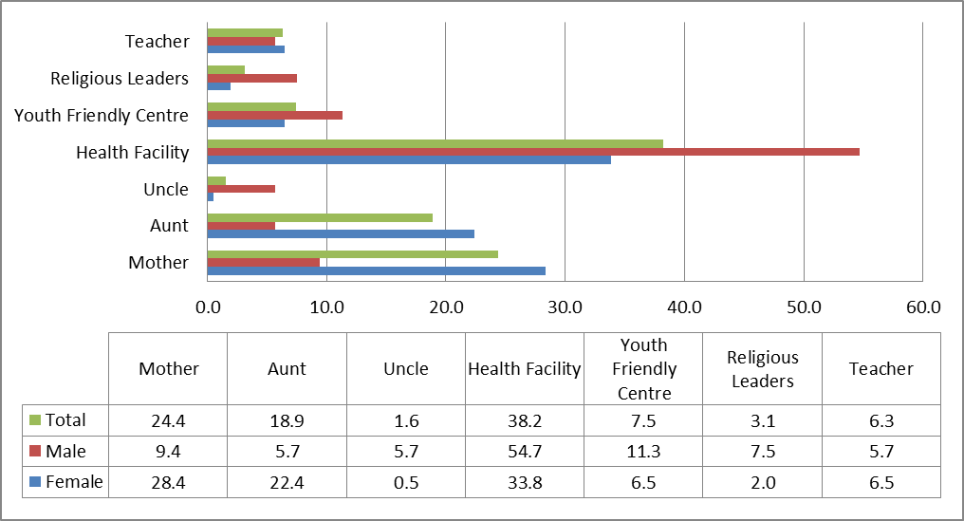

3.4 Adolescents Sexual Behaviours and Practices

3.4.1 Exposure of Young People to Sex and Contraception

A proportion of 72% young people interviewed had never engaged in sexual intercourse a greater proportion of males (35.8%) having had sexual intercourse before as compared to 23.4% of females. A proportion of 2% of the young people interviewed did not respond to the question. Figure 15 shows the proportion of respondents who have ever has sexual intercourse before.
Figure 15: Respondents who have ever had sexual intercourse before (n=254)
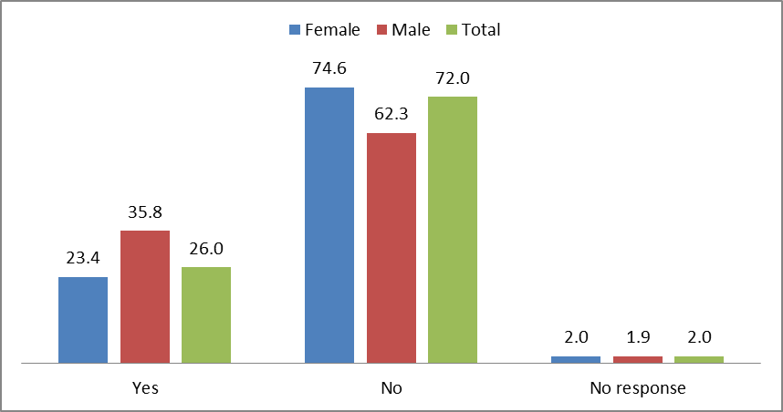

There is a relatively lower proportion (2.8%) of 10-14 age groups having had sexual intercourse, and there is a distinct increase in exposure to sexual behaviour with age as 29.3% of those in the 15-19 age group having had sexual intercourse and a much greater proportion of those in the 20-24 where 41.9% had had sexual intercourse before. Figure 16 shows the statistics of engagement in sex among different age groups.
Figure 16: Respondents who have had sexual intercourse before by age (n=254)
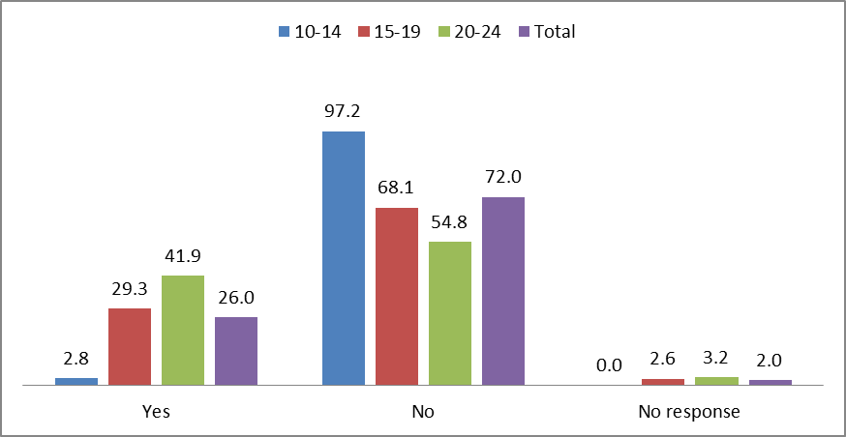
Statistical figures show that there are no young people under the age of 15 using contraception, while 38.8% are using contraception while 45.2% of those aged 20-24 are using contraception. This could also spell out under reporting of those having sexual intercourse. There were also 46.5% not reporting. Figure 17 shows young people using contraceptive methods.
Figure 17: Young People using Any contraception method (n=254)
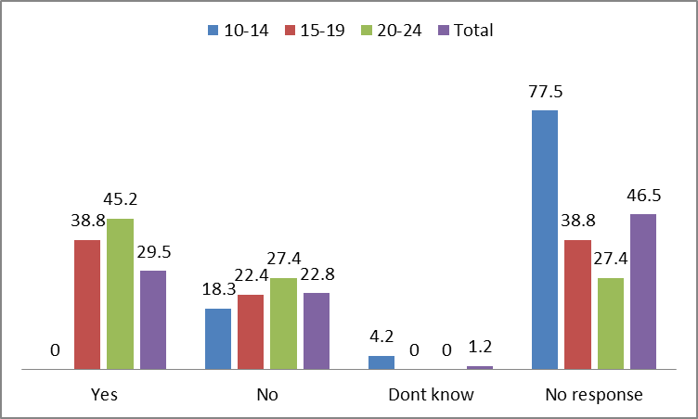

3.4.2 HIV Testing and Prevention Patterns among Young People

A proportion of 44.5% of young people had been tested before with 54.7% of young people in Chitungwiza having been tested for HIV. A proportion of 37.5% of young people in Zvimba had been tested for HIV but with 40.9% not responding to the question. The same trend could be seen in Seke, where 36.7% of the young people interviewed had been tested while 38.3% did not respond to the issue of testing for HIV. All those tested in all areas had received their results, which can be attributed to the efficiency of the service providers as they gear up for testing and treating which can only be functional with an effective system of availing results as quickly as possible before someone leaves the facility. Figure 18 shows the respondents that had tested for HIV.
Figure 18: Respondents who have been tested (n=254)
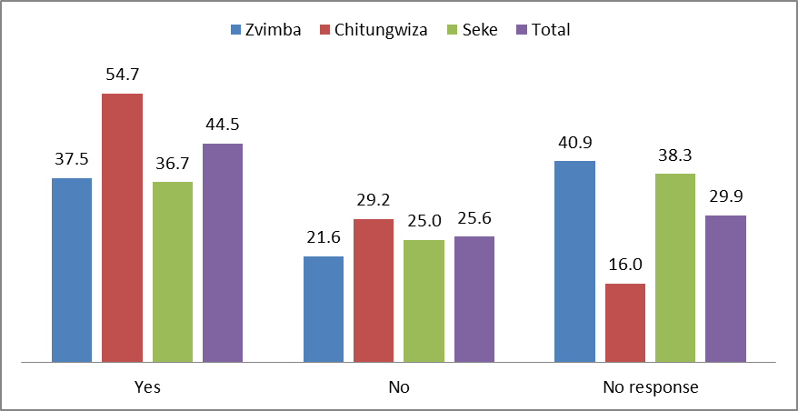
There is evidence that young people know the ABC to prevention although the figures would need to improve, as 28.3% of males and 27.4% of females knew about the ABC to prevention. Figure 19 shows the respondents that know about the ABC to prevention.
Figure 19: Respondents knowing the ABC to Prevention of HIV and AIDS (n=254)
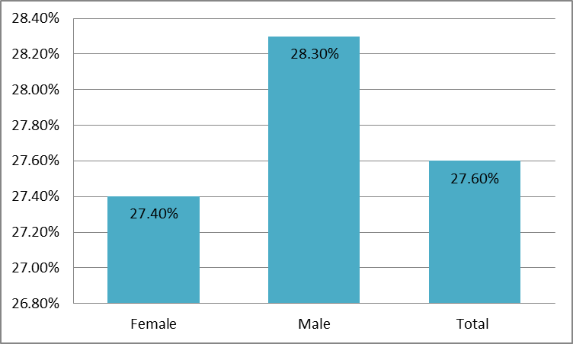

3.4.3 Level of Risk to HIV among Young People

Interviewees were given a chance to determine which level of risk they found themselves in after having been taken through a standard tool of HIV risk shown in Table 5;
Table 5: Standard Tool to Ascertaining Risk for young people
Low Risk | Medium Risk | High Risk
Abstain  Resist Peer Pressure | Use condoms  Same age sexual relationship  Knowledgeable about prevention | Unprotected sex  Transactional sex  Many friends and youth in community having sexual relationships  Intergenerational sex  Out-going especially at night – clubs and discos  Alcohol and Drug Abuse

A proportion of 35% of young people interviewed perceived themselves as in a high risk zone, where 37.3% of females and 26.4% of males, perceived themselves to be in this high risk zone. Figure 20 shows the perception of young people on which risk category they belong to.
Figure 20: Perception of Risk among young people interviewed (n=254)
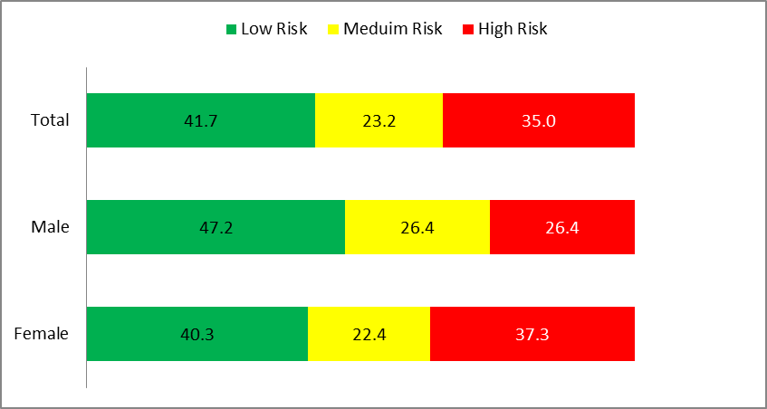

3.5 Gender Roles

3.5.1 Decision Making in the Home

The most important decision to be made in the home was seen as that of the man, with 41% of the young people interviewed feeling that the man makes the important decision. A proportion of 37% also felt that a decision made equally between the man and the woman was the most important, while 18% felt the woman’s decision was the most important. Figure 21 shows the young people’s perception on the most important decision in their home.
Figure 21: Most Important Decision Made at Home (n=254)
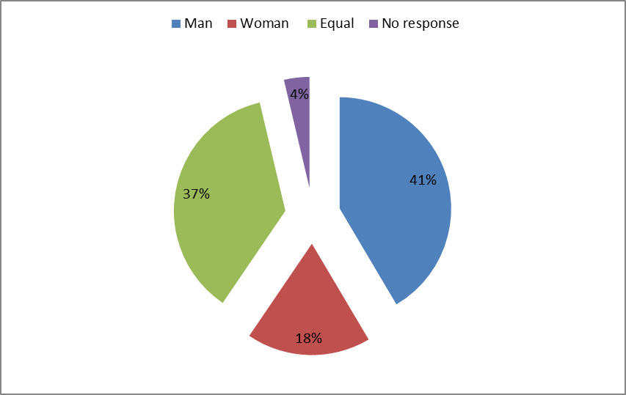

3.5.2 Perception of Gender Based Violence and Early Marriages

A proportion of 10.2% of young people felt that it is acceptable to have early marriages with a bigger sample of males (15.1%) than that of females (9%). This shows a differing view among the sexes attributable to the female usually being the victim rather than the males being the perpetrator. Table 6 shows the difference in perceptions on early marriages among young males and females.
Table 6: Perception of young males and females on acceptability of early marriages (n=254)
Statement | In agreement
 | Female | Male | Total
Do you think early marriages are acceptable? | 9% | 15.1% | 10.2%

The same trend in differences in perception is also evident on domestic violence issues. Overall, 11.4% of young people feel that it is acceptable for a man to beat a woman in the family. However 18.9% males feel it is acceptable as opposed to 9.5% of females. In breaking down the issue of domestic violence 67.7% of females felt it is not right to do so as opposed to 72.3% of males. There is also a disparity in sexes as 60.2% of females feel it is necessary to find out who is wrong when a woman is beaten by a man in a family while 50.9% of males found it necessary to inquire.

Table 7: Perception of Young People on Domestic Violence (n=254)
Statement | In agreement
 | Female | Male | Total
Do you think a man has the right to beat a woman in the family? | 9.5% | 18.9% | 11.4%
If a man has beaten a woman:
- It is necessary to find out who is guilty | 60.2% | 50.9% | 58.3%
- It means that a woman has deserved it | 26.9% | 26.4% | 26.8%
- A man should never beat a woman | 67.7% | 72.3% | 69.7%

Conclusions and Recommendations

4.1 Conclusion

Access to SRH Information and Services: Project areas have health facilities which young people are already comfortable to visit with a significant number of young people feeling that they are comfortable insinuating that there are youth-friendly facilities. However numbers of young people accessing SRH services will still need to improve. The study managed to unearth some barriers that inhibit access to SRH services for young people, which included; societal and peer stigma, cost of resources or lack of knowledge on costs, distance in some areas especially Seke. There was also greater access that was being experienced in Zvimba where demand creation activities had been rolled out in the last phase of the project as the same cannot be said for the new areas of Seke and Chitungwiza where demand still needs to be created.
Knowledge on Sexual and Reproductive Health and Life Skills: It’s clear that knowledge on HIV is high although there is need to deal with some misconceptions especially among the 10-14 age groups. The level for knowledge on SRH rights is appalling across all districts for all young people interviewed, showing that there would be need to provide unwavering support in this area. Young people are conversant on some of the provisions of policy and strategic issues on SRH for young people, but are unaware of some of the important documents where their issues fully sit and which they should be able to hold duty bearers accountable.
Attitudes on Use of Contraception: It is the issue of contraception that comes as an important issue in this area. The use of contraception was widely regarded as “not so important” or rather “taboo” for young people and was fully exercised in this study through findings that young people found use of contraception as inappropriate. The reliability of sources was also topical as young people found it more reliable to visit the health facility for information regardless of the fact that they spend so much time in the community (church, youth centres), family and with peers.
Adolescents Sexual Behaviours and Practices: It is crystal clear that the sexual behaviours of young people put them at risk while key stakeholders and their families would want to think they are not having sexual intercourse, they are. This means they are exposed to risk of HIV, STIs and even GBV. The study unearthed that they still shun from contraception and some deny that they are engaging in sexual intercourse for reasons already raised including societal and peer stigma. HIV testing trends are also low regardless of the young people’s sexual behaviours and practices. The young people through an exercise in the study were able to determine their level of risk and over 30% were in the high risk zone.
Gender Roles: The man was seen as the person with the most important decision in the home with women just there as second fiddles to the males. Although equal decisions were significantly hailed as important there is still the feeling that the male decision is more important. This makes it particularly easy for the young males to feel it is approved to hit a female in the home as was shown by the data collected in the field. It was also particularly clear that more young males are fine with early marriages than their female counterparts who are the victims to early marriages.

Recommendations

- Put in place a full-fledged capacity strengthening for all partners and key stakeholders to be able to create a standard modus operandi and to ensure that the same results are being pushed in all areas, that will also improve monitoring and evaluation efforts;

- Create synergies with service providers for mobile youth friendly centres where young people can receive SRH services for free or at reasonable prices;

- Upscale to other new areas in Zvimba and still service existing areas for greater impact and to reduce duplication and also provide services that are tailor made to the needs of the various districts being cognisant of the different needs particularly due to Zvimba having received some services before the roll out of this project;

- Increase the scope of the project to include school based programming to improve reach;

- Conduct youth friendly and demand creation activities that appeal to young people to include use of creative arts, sports, school based entertainment;

- Create a vibrant roster and conduct family and community based awareness and sensitisation on the gains of the project and the importance for young people in order to reduce societal, family and peer stigma and also to enable them to be reliable sources for SRH information;

- Provide a youth-specific knowledge programme with age and sex specific lessons detailed in a manual guided by the nuances of the study. Issues of contraception should also be topical;

- Social accountability should also be included where the young people are fully inducted on various policies and strategies on SRH and young people and how they can as themselves hold office bearers accountable for any variance with such;

- Mainstream gender issues in the planning, implementation, monitoring and evaluation; and include issues of gender transformation in all sensitisation, awareness, training session of the community, service providers, young people and all stakeholders;

- Wedge a multi-sectoral approach where all key stakeholders participate actively and own the project at community level;

- Ensure adequate and frequent monitoring, knowledge management and dissemination of the project at local, district, country and beyond borders for greater impact.

References
- ACT for Youth Centre of Excellence (2014) Gender and Health Part Four
- Constitution of Zimbabwe Amendement (No. 20) ACT 2013, chapter 2, No 20 (e)
- Government of Zimbabwe (2010) The Zimbabwe Constitution
- Government of Zimbabwe (2012) Zimbabwe National Gender Based Violence Strategy(2012-2015)
- http://www.zw.one.un.org/zundaf/gender-equality
- https://zimbabwe.unfpa.org/en/topics/young-people-2
- Mashangwa, V. (2016). Strategy to End Child Marriages in Zimbabwe. The Chronicle, 2 January, 2016
- Ministry of Health and Child Care (2016) Zimbabwe Population Based HIV Impact Assessment (ZIMPHIA)
- National Adolescent and Youth Sexual and Reproductive Health (ASRH) Strategy II: 2016- 2020.
- The Community dialogues encompassed sessions on comprehensive level of knowledge on gender and its linkages to HIV, GBV and SRHR outcomes
- UNAIDS (2014) UNAIDS Gender Assessment Tool: Towards a gender transformative HIV Response, UNFPA (2011) More than just Culture: Male circumcision for HIV Prevention among the Shangani.

- Zimbabwe National Gender Based Violence Strategy(2012-2015)

- zimbabwe.unfpa.org/topics/gender-based-violence
- ZIMSTAT (2015) Zimbabwe Demographic Health Survey (ZDHS) 2015
- ZIMSTAT (2015) Zimbabwe Multi Indicator Survey (MICS)

Questionnaire

“ENHANCING PARTNERSHIP TO IMPROVE SERVICE PROVISION IN SEXUAL REPRODUCTIVE HEALTH FOR ADOLESCENT GIRLS IN ZIMBABWE”
INFORMED CONSENT

Good morning/afternoon. My name is _______________________________ and I am an Enumerator engaged by Chiedza Child Care Centre. We are in the process of gathering baseline data for the project “Enhancing partnership to improve service provision in sexual reproductive health for adolescent girls in Zimbabwe”. I would very much appreciate your participation since you have been selected to take part in this process. This information will help to improve the quality of the project which will ultimately benefit youth in this community. The discussion will take about 30 of your time. Whatever information you provide will be kept strictly confidential and will not be tied back to you as an individual. Only summary results will be provided to Chiedza Child Care Centre leadership. Participation in this baseline is voluntary and I would want you to share openly and honestly your views and experiences. If you are uncomfortable in answering any question, you do not have to answer it. I however hope that you will answer all the questions since your views are important to the success of this study.

Venue: ________________________________________Date: ______________

Section 1: Demographic Data
No. |  | Question |  |  |  | Response Options |  |  |  |  |  |  | Code |  |  |  |  | Skip rules
101 |  | Interview site
102 |  | District |  |  |  | Harare Southern  Zvimba |  |  |  |  |  |  |  | 01  02
103 |  | Sex of respondent |  |  |  | Female  Male |  |  |  |  |  |  |  | 01  02
104 |  | What is your age?  Age in years  __________________  Circle age range |  |  |  | 10-14  15-19  20-24  Don’t Know  No Response |  |  |  |  |  |  |  | 01  02  03  88  99
105 |  | What is your marital status? |  |  |  | Not married  Married and living with spouse  Married but not living with spouse  Divorced  Separated  Widowed  Don’t Know  No Response |  |  |  |  |  |  |  | 01  02  03  04  05  06  88  99 |  |  |  |  | If not married skip to 107
106 |  | How old were you when you got married? (yrs)
107 |  | What is your religion?  (only one religion required) |  |  |  | Traditional  Christian  Muslim  Apostolic  None  Other (specify): ________________________  Don’t know  No Response |  |  |  |  |  |  |  | 01  02  03  04  05  88  99
108 |  | What is your current/highest completed level of education?  Circle current/highest level of education |  |  |  | Never Attended School  Primary school (grades 1-7)  Secondary school (form1-4)  High School (form 5-6)  Vocational Training College  University/Polytechnic  Other (specify): ________________________  Don’t Know  No Response |  |  |  |  |  |  |  | 01  02  03  04  05  06  07  88  99
109 |  | Are you currently in school? |  |  |  | Yes  No |  |  |  |  |  |  |  | 01  02 |  |  |  |  | If No Skip to111
110 |  | If not in school, what are you doing currently?
111 |  | What do you do MOST to earn a living?  Do not prompt, circle all mentioned |  |  |  | Mentioned |  |  |  |  |  | Yes |  | No
 |  |  |  |  |  | Casual labour/piece jobs  Trading(buying and selling)  Domestic work  Subsistence farming (crop or animal rearing)  Commercial farming (crop or animal rearing)  Skilled labour (Carpentry, plumbing, electrician)  Mineral mining/panning  Professional (specify): ________________________  Housewife  Bartering / selling of assets  Other (specify): ________________________  Don’t Know  No Response |  |  |  |  |  | 01  01  01  01  01  01  01  01  01  01  88  99 |  | 02  02  02  02  02  02  02  02  02  02 |  |  |  |  | Please don’t read out responses
112 |  | Are there people who are under your support in the household? |  |  |  | Yes  No |  |  |  |  |  | 01  02 |  | If yes, How many?........
113 |  | Are you living with a disability? |  |  |  | Yes  No  No response |  |  |  |  |  | 01  02  99
Section 2: Access to SRH information and services
201 |  | In the past year, have you ever visited a health facility or other place in this community in search of SRH services? |  |  |  | Yes  No  Wanted to but the services are unavailable/accessible |  |  |  |  |  | 01  02  03
202 |  | Do you feel you have easy access to SRH services in your community each time you need them? |  |  |  | Yes  No |  |  |  |  |  | 01  02 |  |  |  |  |  |  | If NO, please go to Q204
203 |  | If yes, Which ones do you feel you can easily access in your community each time you need them? |  |  |  | Mentioned |  |  |  |  |  | Yes |  | No
 |  |  |  |  |  | SRH or sexuality education and counselling  Miscarriage/Post abortion care services  Provision of contraceptives (pills, condoms, etc)  STI testing and screening  STI treatment services  Voluntary HIV testing  Youth Friendly Corners/Centre services at clinics  Family planning services including counselling  Cervical Cancer screening  Pregnancy care and delivery  Referral to other service providers for further management  Other……………………………………………..  Other…………………………………………….. |  |  |  |  |  | 01  01  01  01  01  01  01  01  01  01  01  01  01 |  | 02  02  02  02  02  02  02  02  02  02  02 |  |  |  |  | Multiple responses accepted.  Please do not read out responses
204 |  | Please indicate the place(s) in your community where you easily access the services |  |  |  | Place(s)……………………………………..…………………………………
205 |  | On average, what distance should you travel to this place to access these SRH services? |  |  |  | Less than 1km  Between 1km and 3kms  Between 3km and 5kms  Between 5km and 8kms  Above 8kms |  |  |  |  |  | 01  02  03  04  05
206 |  | Do you have easy access to SRH information in your community each time you need it? |  |  |  | Yes  No |  |  |  |  |  | 01  02 |  |  |  |  |  |  | IfNO, please skip to 217
207 |  | If yes, please indicate the type of information you easily access? |  |  |  | Mentioned |  |  |  |  |  | Yes |  | No
 |  |  |  |  |  | Puberty  Gender and sexuality  Condom use  Pregnancy prevention  HIV prevention and treatment  STI prevention and treatment  Cervical cancer prevention and treatment  Dating and relationships  Life skills including negotiation skills |  |  |  |  |  | 01  01  01  01  01  01  01  01  01 |  | 02  02  02  02  02  02  02  02  02 |  |  |  |  | Multiple responses accepted here
208 |  | Indicate your major sources for SRH information in this community? |  |  |  | Mentioned |  |  |  |  |  | Yes |  | No
 |  |  |  |  |  | IEC materials distributed by NGOs and MoHCC  Radio  Television  Peer educators in community and schools  Youth Friendly Corners at local clinics  Newspapers  Internet  School Guidance and Counselling sessions  AIDS clubs in school  Work place education programmes  Local clinics and hospitals  Training workshops by NGOs  Intergenerational dialogue sessions at home or community level |  |  |  |  |  | 01  01  01  01  01  01  01  01  01  01  01  01  01 |  | 02  02  02  02  02  02  02  02  02  02  02  02  02 |  |  |  |  | Multiple responses accepted.
209 |  | What was the reason for your most recent visit to a facility that offer SRH services |  |  |  | Education and counseling regarding SRH  VCT for HIV  Miscarriage/Post-abortion care services  Family planning services  STI treatment and counseling  Pregnancy care and delivery  Mental health and psychosocial support  Vaccination  PEP  PREP  VMMC  SGBV  To get condoms  No response  Don’t know |  |  |  |  |  | 01  02  03  04  05  06  07  08  10  11  12
210 |  | Would you return to the health facility again? |  |  |  | Yes  No  No response  Don’t know |  |  |  |  |  | 01  02  99  88 |  |  |  |  |  |  | If yes, go to 212
211 |  | If No, what is the reason that you won’t return to the health facility?  Circle All Mentioned |  |  |  | Takes too much time  Too difficult to get there  Costs are too much  Too embarrassing  Not enough privacy  Mistreated by staff  No staff of the same sex available  The services were not available  Other (specify)___________________  No answer  Don’t know |  |  |  |  |  | 01  02  03  04  05  06  07  08  09  99  88
212 |  | Whom did you talk to or see at the health facility the last time you went?  Circle All Mentioned |  |  |  | Doctor  Nurse  Nurse Aid  Peer educator/counselor  Other (specify)________________  No answer  Don’t know |  |  |  |  |  | 01  02  03  04  99  88
213 |  | Was the service provider:  Circle All Mentioned |  |  |  | Mentioned  Read all and tick mentioned |  |  |  |  |  | Yes |  | No
 |  |  |  |  |  | Knowledgeable and well-qualified  Friendly and polite  Interested in you and your problems  A good communicator  Respectful  Concerned about your privacy  Honest and direct  A good listener  Able to help you  No response |  |  |  |  |  | 01  01  01  01  01  01  01  01  01 |  | 02  02  02  02  02  02  02  02  02
214 |  | Would you feel comfortable going to the local/nearest health facility found in your area for sexual and reproductive health services? |  |  |  | Yes  No  Did not respond |  |  |  |  |  | 01  02  99 |  |  |  |  |  |  | If yes, go to 217
215 |  | Why wouldn’t you feel comfortable going to the local/nearest health facility in your area for sexual and reproductive health services?  Circle All Mentioned |  |  |  | Not confidential  Too embarrassed  Staff unfriendly  Costs too much  Other (specify)_____________  No response  Don’t know |  |  |  |  |  | 01  02  03  04  05  99  88
217 |  | Overall, what do you consider to be the major barrier for youth to accessing services and information in your community or district in general? |  |  |  | Mentioned |  |  |  |  |  | Yes |  | No
 |  |  |  |  |  | Negative attitude from staff at local clinics/hospital  Inconvenient opening hours at local clinic, Hospital  Inconvenient opening hours at YF  Cost at the local clinics/hospitals  Long distances that I travel to access the services  Labelling or stigmatisation by peers and community members  Unavailability of services at the local clinic/hospital  Lack of confidentiality  Other…………………………………………… |  |  |  |  |  | 01  01  01  01  01  01  01  01 |  | 02  02  02  02  02  02  02  02 |  |  |  |  | Multiple responses accepted.  Please do not read out responses
218 |  | What can be done to improve youths ‘access to SRH services and information in your community or district? |  |  |  | ………………………………………………………………………………………………………………………………………………………………………………………………………………………………………………………………………………………………………………………………………………………………
219 |  | In the past 2 years did you receive any training on Life skills, leadership and SRH, if any? |  |  |  |  |  |  |  |  |  | Yes |  | No
 |  |  |  |  |  |  |  |  |  |  |  | 01 |  | 02 |  |  |  |  | If No skip to 222
 |  | If yes indicate the Type of training | Topics covered |  |  |  |  | New skills or knowledge acquired |  |  |  |  |  | Year |  |  |  |  | Who trained you?
220 |  | Which skills and knowledge if any, are you applying in daily life? |  | …………………………………………………………………………………………………………………………………………………………………………………………………………………………………………………………………………………………………………………………………………………………………………………………………………………………………………………………………………………
221 |  | Please give examples of cases where the skills or knowledge helped you |  | ………………………………………………………………………………………………………………………………………………………………………………………………………………………………………………………………………………………
222 |  | Which areas do you need training to improve your SRH knowledge, if any? |  | ………………………………………………………………………………………………………………………………………………………………………………………….  ……………………………………………………………………………………………  …………………………………………………………………………………………………………………………………………………………………………………………
223 |  | Each time you seek SRH services and products such as post abortion care, contraceptives, clinical care (STI screening and testing, HIV testing and counselling) how do your family members, community, peers and health personnel at local clinics react? |  | a)Family reaction…………………………………………………………………………………………………………………………………………………………………………….
 |  |  |  | b) Peers and community……………………………………………………………………………………………………………………………………………………………………………
 |  |  |  | c) Health Personnel……………………………………………………………………………………………………………………………………………………………………………….
Section 3:Knowledge on Sexual and Reproductive Health and Life skills
No. |  | Question |  |  |  |  | Response Options |  |  |  | Code |  |  |  |  |  |  |  | Skip rules
301 |  | Have you ever heard of the virus HIV or an illness called AIDS? |  |  |  |  | Yes  No  Don’t know  No response |  |  |  | 01  02  88  99
302 |  | Can people get infected with the HIV/AIDS virus through witchcraft or other supernatural things? |  |  |  |  | Yes  No  Don’t know  No response |  |  |  | 01  02  88  99
303 |  | Can people get the HIV/AIDS virus by getting injections with a needle that was already used by someone with HIV? |  |  |  |  | Yes  No  Don’t know  No response |  |  |  | 01  02  88  99
304 |  | Is it possible for a healthy looking person to have the HIV/AIDS virus? |  |  |  |  | Yes  No  Don’t know  No response |  |  |  | 01  02  88  99
305 |  | Can the HIV virus be transmitted from a mother to a baby:
 |  | a) During pregnancy? |  |  |  |  | Yes  No  Don’t know  No response |  |  |  | 01  02  88  99
 |  | b) During delivery? |  |  |  |  | Yes  No  Don’t know  No response |  |  |  | 01  02  88  99
 |  | c) By breast-feeding? |  |  |  |  | Yes  No  Don’t know  No response |  |  |  | 01  02  88  99
306 |  | If you or a member of your family became infected with the HIV virus would you want it to remain a secret? |  |  |  |  | Yes  No  Not sure/depends  Don’t know |  |  |  | 01  02  03  88
307 |  | Would you buy vegetables from a person you know has HIV/AIDS? |  |  |  |  | Yes  No  Don’t know |  |  |  | 01  02  88
308 |  | Do you think carrying condoms with you is a good practice for young people? |  |  |  |  | Yes  No  Sometimes  Don’t know |  |  |  | 01  02  03  88
309 |  | Are there any HIV testing and counselling services (HTS) in your area? |  |  |  |  | Yes  No  Don’t know |  |  |  | 01  02  88
310 |  | Who provides HTS services in your area? |  |  |  |  | Youth Friendly Corners  Clinics  The District hospital  New Start Centres  VCT outreach  Don’t Know |  |  |  | 01  02  03  04  05  88
311 |  | In your view, what does SRH mean?
312 |  | Do you know at least 2 sexual reproductive health rights for youths? |  |  |  |  | Yes  No |  |  |  | 01  02
 |  | If yes, please list at least 2 SRH rights for youths you know? |  |  |  |  | ………………………………………………………………………………………………………………………………………………………………………………………………………………………………………………………………………………………………………………………………………………………………
313 |  | In your own opinion, which is the most effective way of preventing pregnancies, STIs and HIV? |  |  |  |  | Abstinence  Using condoms  Other: Specify  Don’t Know |  |  |  | 01  02  03  88
314 |  | Which Sexually Transmitted Diseases do you know? Circle all STDs stated |  |  |  |  | Gonorrhoea  Syphilis  Hepatitis B and C  Herpes  Genital Warts  Other(specify).................................................................. |  |  |  | 01  02  03  04  05  06
315 |  | Please mention any cancers of the reproductive system that you are aware of.  Do not prompt, circle all mentioned |  |  |  |  | Breast Cancer  Cervical Cancer  Cancer of the uterus  Prostate Cancer  Cancer of the penis  Cancer of the testicles  Don’t Know  No Response |  |  |  | 01  02  03  04  05  06  88  99
316 |  | Do you know examples of life skills? |  |  |  |  | Yes  No |  |  |  | 01  02
317 |  | If yes, please give examples of life skills you know? |  |  |  |  | ………………………………………………………………………………………………………………………………………………………………………………………………………………………………………………………………………………………………………………………………………………………………
318 |  | Are you familiar with the provisions of the National ASRH Strategy? |  |  |  |  | Yes  No |  |  |  | 01  02
319 |  | If yes, can you please summarize what you know about it? |  |  |  |  | ……………………………………………………………………………………………………………………………………………………………………………….
320 |  | Are you aware of the Domestic Violence Act (2007) and its provisions? |  |  |  |  | Yes  No  No Response |  |  |  | 01  02  88
321 |  | Have you ever heard of the Child Protection Act? |  |  |  |  | Yes  No  No Response |  |  |  | 01  02  88
322 |  | The Criminal Law – Sexual Offences Act(2001) says there is no such thing as marital rape since sex is a conjugal right. Is this true or false? |  |  |  |  | True  False  Don’t know |  |  |  | 01  02  88
323 |  | Is abortion a criminal offence in Zimbabwe? |  |  |  |  | Yes  No  Don’t know |  |  |  | 01  02  88
324 |  | Please mention any negative health consequences of abortion that you know of:  Circle all mentioned, do not prompt |  |  |  |  | Hemorrhaging (excessive bleeding)  Infection or sepsis  Damage to reproductive organs (perforation, laceration)  Damage to other organs  Reproductive health cancers (cervical, ovarian)  Complications with later pregnancies  Psychological complications (anxiety, depression, alcohol use, drug use and suicidal behavior)  Death  Other (specify)  Don’t Know  No Response |  |  |  | 01  02  03  04  05  06  07  08  88  99
325 |  | Do you know what family planning is about? |  |  |  |  | Yes  No  Don’t know |  |  |  | 01  02  88
326 |  | Are family planning services readily available in your area? |  |  |  |  | Yes  No  Don’t know |  |  |  | 01  02  88 |  |  |  |  |  | If No skip to 401
327 |  | If Yes, which family planning services are readily available in your area?  Circle all appropriate |  |  |  |  | Female sterilization  Male sterilization,  Pill  Intra Uterine Device(IUD) Injections  Implants  Female condom  Male condom  Did not Respond  Not applicable |  |  |  | 01  02  03  04  05  06  07  88  99
Section 4: ASRH Attitudes and beliefs
No. | Question |  |  |  | Response Options |  |  |  | Code |  |  |  |  |  |  | Skip rules
401 | Do you intend to use a contraceptive (including condoms) the next time/first time you have sexual intercourse?  Read out and prompt for only one response, |  |  |  |  |  | Yes I plan to use and will not have sex without it |  | 01
 |  |  |  |  |  |  | Yes I plan to use as long it is convenient |  | 02
 |  |  |  |  |  |  | Yes I plan to use if my partner doesn’t object |  | 03
 |  |  |  |  |  |  | Yes I plan to use if my partner insists on it |  | 04
 |  |  |  |  |  |  | I have no plan to use contraceptive |  | 05
 |  |  |  |  |  |  | I haven’t thought about it |  | 06
 |  |  |  |  |  |  | Did not respond |  | 88
402 | Would you rather want to have children now or in the future? |  |  |  |  |  | Now  Future  Never  Don’t know |  |  | 01  02  03  88
403 | At what age would you wish to have your first child?  Age:  Circle appropriate response |  |  |  |  |  | <18 years  18-20 years  21-24 years  25-29 years  30-35 years  >35 years |  |  | 01  02  03  04  05  06
404 | What would be your primary concerns if you were to become pregnant (for female respondents)/impregnated (for male respondents) before you were ready?  Circle all mentioned but do not prompt |  |  |  |  |  | How it affects my education  What my parents will say/do  What my community/church will say/do  I’m too young to get married/have a baby  Will I get married  Don’t Know  No Response |  |  | 01  02  03  04  05  88  99
405 | What action would you take if you became pregnant(for female respondents)/impregnated (for male respondents) before you were ready? |  |  |  |  |  | Terminate the pregnancy  Deliver and keep the baby  Deliver and give the child out for adoption  Commit suicide  Don’t know  No Response |  |  | 01  02  03  04  88  99
406 | Should teenagers (13-19 years old) be permitted to use family planning methods? |  |  |  |  |  | Yes  No  Don’t know  No Response |  | 01  02  88  99
407 | Do you think that young people’s knowledge of contraception encourages them to be promiscuous? |  |  |  |  |  | Yes  No  Sometimes  Don’t know  No Response |  | 01  02  03  88  99
408 | Do you approve of unmarried youths using contraceptives to avoid pregnancy and STIs? |  |  |  |  |  | Yes  No  Sometimes  Don’t know  No Response |  | 01  02  03  88  99
409 | Do you feel that you are in a position to make informed decisions about your sexual behavior and relationships? |  |  |  |  |  | Yes  No  I need more information  Not sure |  | 01  02  03  88
410 | Which SRH information is most important to you?  Circle all mentioned, do not prompt |  |  |  | Puberty  Sexual reproductive rights  Family planning/Prevention of pregnancy  Prevention of STI  Prevention of HIV and AIDS  Cancers of the reproductive system |  |  |  | 01  02  03  04  05  06
411 | Do you feel that parents and communities fully understand your needs as youth? |  |  |  |  |  | Yes  No  Don’t know  No Response |  |  |  | 01  02  88  99
 | if no, specify reason
412 | In your community, who would you consider the most reliable source of information on any ASRH issues? |  |  |  | Mother  Aunt (tete, mainini, maiguru)  Uncle( sekuru, bamunini, bamukuru)  Health Facility(nurse, doctor)  Youth friendly centre  Religious leader  Teacher |  |  |  | 01  02  03  04  05  06  07
413 | Have you participated in any ASRH activities?  circle all appropriate |  |  |  | Yes, at school  Yes, in the community  Yes, both in school and community  No  Sometimes |  |  |  | 01  02  03  04  05

Section 5: Adolescent Sexual Behaviors and practices
No. | Question | Response Options | Code | Skip rules
501 | Have you ever had sexual intercourse? | Yes  No  No response  Don’t know | 01  02  99  88 | If Yes, skip to 503
502 | If No, at what age would you like to have sexual intercourse for the first time? | Age………………………………………………..  After marriage  No response  Don’t know | 77  99  88 | Skip to 509
503 | At what age did you first have sexual intercourse? | Age………………………………………………..  After marriage  No response  Don’t know | 77  99  88
504 | How old was the person with whom you had sexual intercourse for the first time? | Age………………………………………………..  No response  Don’t know | 99  88
505 | Thinking about the first time you had sexual intercourse, could you tell me which statement best describes your experience?  Circle All Mentioned | I was willing  I was persuaded  I was tricked  I was forced  I was raped  I was coerced (received money, food,  clothing, gifts)  I was expected to do it as part of my job  No response  Don’t know | 01  02  03  04  06  07  08  99  88
506 | Are you currently doing something or using any method to delay or avoid getting pregnant? | Yes  No  No response  Don’t know | 01  02  99  88
507 | If Yes, which methods are you using?  Do not prompt, circle all mentioned | Female sterilization  Male sterilization,  Pill  IUD  Injections  Implants  Female condom  Male condom  Periodic abstinence  Withdrawal | 01  02  03  04  06  07  08  09  10  11
508 | Have you ever had sex with a non- marital or non-cohabiting partner without protection? | Yes  No  No response  Don’t know | 01  02  99  88
509 | Have you ever been tested to see if you have HIV, the virus that causes AIDS? | Yes  No  No response  Don’t know | 01  02  99  88 | If No, skip to 512
510 | When was the last time you were tested? | 0-6 months ago  6-12 months ago  12 – 23 months ago  More than 2 years ago | 01  02  03  04
511 | Did you receive your results when you were tested? | Yes  No  Did not answer | 01  02  99
512 | Do y  ou know the ABC of prevention? | Yes  No  No response  Don’t know | 01  02  99  88
513 | Regarding the ABC of prevention, what are you doing to prevent infection with HIV or STIs? | I am Abstaining from sex  I am Faithful to one partner  I use Condoms each time  I use condoms each time and I am faithful to one partner | 01  02  03  04
514 | In your own opinion, what is your perceived level of risk of infection with HIV for the youths in your area based on the categories below: | Low risk  Medium risk  High risk | 01  02  03
Perception of risk key (read to respondent)
LOW RISK
They abstain
Resist peer pressure
MEDIUM RISK
Engage in sexual intercourse using condoms
Same age sexual relationships
Knowledgeable about prevention.
HIGH RISK
Engage in un-protected sex
Too many youth get involved in sexual relationships.
Transactional sex
Lots of intergenerational sexual relationships
Too many evening functions like discos and modelling
Alcohol and drug abuse

Section 6: Gender Roles
No. | Question | Response Options |  | Code | Skip rules
701 | Who’s opinion is more important in decision making in family affairs? | Man’s  Woman’s  Both have equal rights  Difficult to answer  No response |  | 01  02  03  77  99
702 | Do you think early marriages (<18) are acceptable? | Yes  No  Difficult to answer  No response |  | 01  02  77  99
703 | Do you think a man has the right to beat a woman in a family? | Yes  No  Difficult to answer  No response |  | 01  02  77  99
704 | If a man has beat up a woman:
704.1 | It is necessary to find out who was guilty initially |  | Yes  No  Difficult to answer  No response | 01  02  77  99
704.2 | It means that a woman has deserved it |  | Yes  No  Difficult to answer  No response | 01  02  77  99
704.3 | A man should never beat a woman |  | Yes  No  Difficult to answer  No response | 01  02  77  99
Thank you for your time!!!
Name of Interviewer:
Date checked by supervisor
Name of Supervisor and signature

https://zimbabwe.unfpa.org/en/topics/young-people-2
Ministry of Health and Child Care (2016) Zimbabwe Population Based HIV Impact Assessment (ZIMPHIA)
Zimbabwe Demographic Health Survey (2015).
Ibid
National Adolescent and Youth Sexual and Reproductive Health (ASRH) Strategy II: 2016- 2020.

